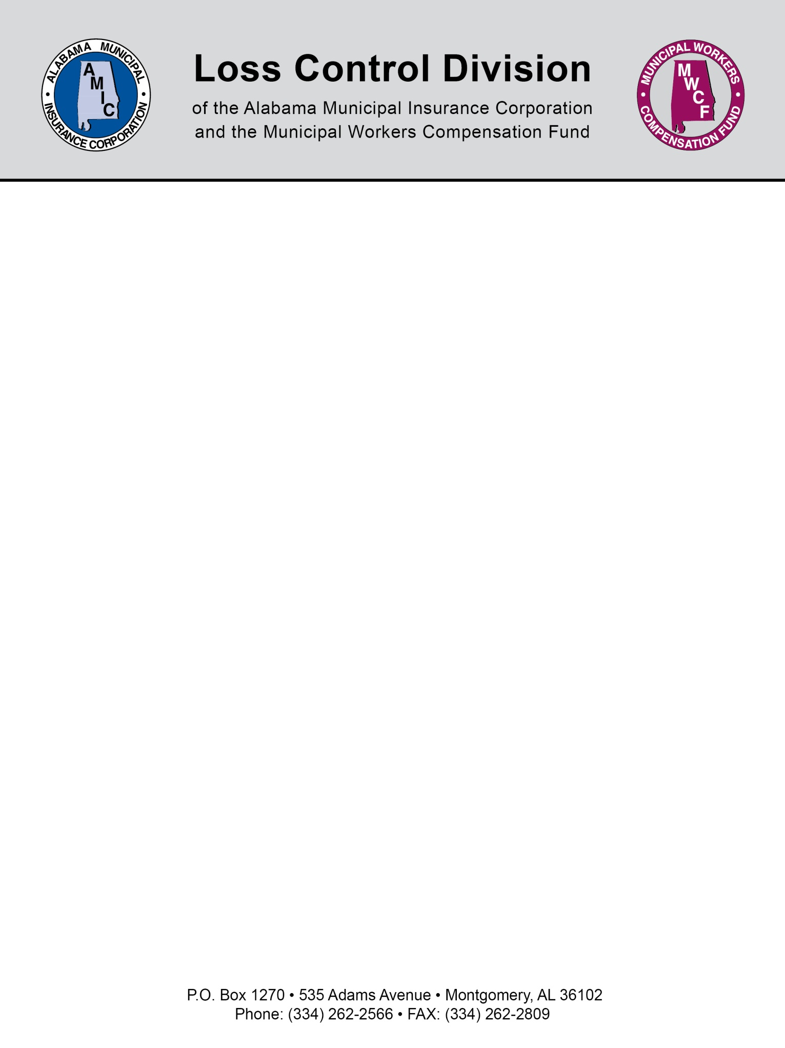

Emergency Vehicle Driver Guidelines
“Best Practices”

1. Allow only trained and certified drivers to operate emergency vehicles.

- Minimum age for all drivers should be 21.
- Successful completion of EVOC (Emergency Vehicles Operator Course).
- Drivers must possess a valid driver’s license.
- Drivers should have a minimum of two years driving experience.
- MVR check should reveal no more than one moving violation within the last 12 months.
- Drivers with traffic stop or violation related to drugs or alcohol should not be allowed to drive.
- All new drivers should be given driver training under the supervision of a certified and experienced driver, preferably an officer.

2. Inspection of the vehicle is the responsibility of the driver.

- All emergency vehicles should be inspected on a regular basis. All inspections must be documented.
- Any defect should be noted and repaired prior operation the vehicle or the vehicle should be removed from service until necessary repairs are made.
- All equipment should be properly secured prior to operating the vehicle.
- Emergency lighting and audible signals should be tested prior leaving the station.

3. Other Safety Considerations

- Driver and all passengers must wear a seatbelt while the vehicle is in operation.
- Texting and driving is strictly prohibited.
- Driver must obey all traffic laws during non-emergency operation. Emergency operations of a vehicle can be found under Alabama Law Section 32-5A-7.
- Only designated “emergency vehicles” should be used for responding to emergency calls no personal vehicles.
- All drivers must drive with due regard for the safety of all other drivers on the roadway.
- A spotter should be used when backing; when a spotter is unavailable the driver must perform a walk around to look for hazards.

4. Laws Pertaining Emergency Vehicles

Section 32-5A-7

Authorized emergency vehicles.

(a) The driver of an authorized emergency vehicle, when responding to an emergency call or when in the pursuit of an actual or suspected violator of the law or when responding to but not upon returning from a fire alarm, may exercise the privileges set forth in this section, but subject to the conditions herein stated.
(b) The driver of an authorized emergency vehicle may:
(1) Park or stand, irrespective of the provisions of this chapter;
(2) Proceed past a red or stop signal or stop sign, but only after slowing down as may be necessary for safe operation;
(3) Exceed the maximum speed limits so long as he does not endanger life or property;
(4) Disregard regulations governing direction of movement or turning in specified directions.
(c) The exemptions herein granted to an authorized emergency vehicle shall apply only when such vehicle is making use of an audible signal meeting the requirements of Section 32-5-213 and visual requirements of any laws of this state requiring visual signals on emergency vehicles.
(d) The foregoing provisions shall not relieve the driver of an authorized emergency vehicle from the duty to drive with due regard for the safety of all persons, nor shall such provisions protect the driver from the consequences of his reckless disregard for the safety of others.
(Acts 1980, No. 80-434, p. 604, §1-106.)

Section 32-5A-115

Operation of vehicles on approach of authorized emergency vehicles; signals on emergency vehicles; duty of emergency vehicle driver.

(a) Upon the immediate approach of an authorized emergency vehicle equipped with at least one lighted lamp and audible signal as is required by law, the driver of every other vehicle shall yield the right-of-way and shall immediately drive to a position parallel to, and as close as possible to, the right-hand edge or curb of the roadway clear of any intersection and shall stop and remain in such position until the authorized emergency vehicle has passed, except when otherwise directed by a police officer.
(b) This section shall not operate to relieve the driver of an authorized emergency vehicle from the duty to drive with regard for the safety of all persons using the highways.
(c) Authorized emergency vehicles shall be equipped with at least one lighted lamp exhibiting a colored light as hereinafter provided visible under normal atmospheric conditions from a distance of 500 feet to the front of such vehicle and a siren, exhaust whistle, or bell capable of giving an audible signal. The color of the lighted lamp exhibited by police vehicles may be red or blue and the color of the lighted lamp exhibited by the fire department and other authorized emergency vehicles, including ambulances, shall be red. No vehicle other than a police vehicle will use a blue light. An amber or yellow light may be installed on any vehicle or class of vehicles designated by the Director of Public Safety, but such light shall serve as a warning or caution light only, and shall not cause other vehicles to yield the right-of-way. This provision shall not operate to relieve the driver of an emergency vehicle from the duty to drive with due regard for the safety of all persons using the highway nor shall it protect the driver of any such vehicle from the consequences of an arbitrary exercise of such right-of-way.
(Acts 1980, No. 80-434, p. 604, §4-106; Acts 1981, No. 81-803, p. 1412, §1.)

NOTE: This document is not intended to be legal advice. It does not identify all the issues surrounding the particular topic. Public agencies are encouraged to review their procedures with an expert or an attorney who is knowledgeable about the topic. Reliance on this information is at the sole risk of the user.

Revised 9/2013

